FORENSIC ACCOUNTING USING OUTLIER DETECTION ALGORITHMS

  - Machine Learning for Accounting

  - Forensic Accounting

  - Machine Learning for Forensic Accounting

  - Understanding Outliers

    - Global Outlier Detection Methods

    - Local Outlier Detection Methods

      - Local Outlier Factor

      - Reachability Distance

      - Local Reachability Density

      - LOF Calculation

      - Local Outlier Probability

  - Detecting Fraudulent Transactions Using LoOP

  - Business Insights and Conclusion

  - Implementation Using R: Outlier Detection for Identifying Fraudulent Transactions

  - Appendix: Glossary of Accounting Terms

  - Understanding the Chapter

LEARNING OBJECTIVES
- Use machine-learning models for accounting
- Understand forensic accounting
- Identify outliers for forensic accounting
- Choose methods for global and local outlier detection
- Detect local outliers for forensic accounting
- Use LoOP to identify fraudulent accounts

MACHINE LEARNING FOR ACCOUNTING

Automation tools are regularly used in accounting. Robotic process automation can perform activities such as copying and pasting data between various applications or reconciling and cross-referencing data between different systems.¹ These tools are used for tracking progress of the annual audit plan, monitoring key risk indicators, populating management report templates, ensuring a balanced scorecard for an internal audit, and evaluating accounting data quality. Please see the glossary in Section 11.8 for some definitions of accounting terms used in this chapter. Recently, this automation also has started incorporating machine-learning tools.² Machine-learning algorithms can receive an invoice, match it to a purchase order, determine which expense account to charge, and place it in a pool of documents for payment; a human expert can then review the documents and release them for payment. Machine learning can help with tax-related activities. As tax laws continue to grow more complex and the Internal Revenue Service processes for identifying a taxpayer for an audit become more sophisticated, machine learning may allow tax accountants to better predict deductions that will be disputed by the IRS and identify the regulations that allow for those deductions. Machine-learning algorithms can also help in contract analysis. These algorithms can be used to review documents related to lease accounting and revenue recognition standards as well as other business activities such as mergers and acquisitions.
Text analysis is used in accounting to compile large quantities of unstructured data that would be challenging to manually compile and synthesize. For instance, management and annual reports, news releases, company web pages, earning call transcripts, and so on are compiled to gather information about stocks, new products, or even sentiment expressed in financial reports that can affect investor perception.³
An important application of the predictive power of analytics is in the area of forensic accounting. Forensic accounting can be considered performing financial detective work. It involves searching through numerous financial records and transactions to uncover any abnormalities that could be indicative of fraudulent activities. Evidence of suspicious transactions may indicate employee fraud and could be used in a court of law. The different activities that can be considered fraudulent in an organizational setting can fall into categories such as financial theft by customers or employees, debt defaults, securities fraud, tax evasion, and money laundering. For the purposes of this chapter, we will use the example of corporate credit card fraud.

FORENSIC ACCOUNTING
Let’s work with the example of Ogenes, a hypothetical health care equipment and service company with more than 1,000 employees. Ogenes has given its employees a corporate credit card that they can use for business-related expenses such as travel and meals with clients. While most of the employees use their cards solely for business expenses, there have been cases where a small number of employees have used their cards for personal expenses. Ogenes’s goal is to identify such fraudulent usage before it becomes a big drain on the company’s assets. The challenges Ogenes faces in identifying fraudulent usage are similar to the ones faced in identifying activities like vendor fraud, tax fraud, money laundering, and wire transfer fraud. While a vast majority of accounting transactions are legitimate, a small group of transactions are fraudulent. Despite the relatively small number of fraudulent
transactions, they cost the global economy over $5 trillion each year.⁴ Identifying fraud mainly relies on finding anomalous transactions or entries that do not appear like the majority of other transactions. Such identification falls under the broad umbrella of forensic accounting.

Even in the recent past, accountants have had to go over numerous transactions to flag fraudulent activities, resulting in a huge investment of resources. However, as machine-learning algorithms or models have grown more efficient and powerful, forensic accounting has become automated. Machine- learning models can easily be taught to distinguish between regular and fraudulent expenses, and they offer several distinct advantages. First, these methods have increased the efficiency with which fraud can be investigated. The Abnormal Trading and Link Analysis System (ATLAS) of the Securities and Exchange Commission (SEC) can identify insider trading by using trading data and other sources of

information to deduce if stock trades have taken place based on prohibited information.⁵ Second, these methods help uncover fraud that was almost impossible to find just a few years back. Forensic accountants analyzed 500 million Airbus documents and found evidence of fraud and bribery that led to
€3.6 billion (US$3.8 billion) in fines in 2021.⁶ Third, machine-learning methods reduce inconsistencies that occur when transactions are flagged and reviewed by different individuals. The Centers for Medicare and Medicaid Services use machine-learning methods to promptly identify fraud within the health insurance system as opposed to less efficient methods that rely on people reporting a fraud they experienced using consumer hotlines or information from whistle-blowers who witnessed a fraud.⁷ Fourth, machine-learning methods offer an organization the ability to flag fraud in real time so remedial steps can be taken quickly. Visa has deployed algorithms that can constantly check transactions and
flag those that might be fraudulent. Finally, these methods are cost effective and make forensic accounting accessible to smaller organizations.

MACHINE LEARNING FOR FORENSIC ACCOUNTING
There are two ways to deploy machine-learning models to detect financial fraud. If firms have records of previous examples of fraudulent behavior (i.e., they have labeled data), they can use supervised algorithms such as support vector machines or deep learning algorithms to flag future fraudulent transactions. However, firms using supervised algorithms face two challenges. First, they deal with sophisticated fraudsters who keep changing their tactics to avoid being flagged. These changing tactics alter the input features given to the model, making prediction difficult. Moreover, changing tactics make the previously obtained labeled data less useful. Second, there is a big imbalance between data points labeled as fraud and not fraud because a majority of data points are generated from legitimate transactions, with only a small number stemming from fraudulent transactions. Such an imbalance results in many supervised algorithms labeling fraudulent transactions as legitimate. Given these challenges, many firms have to identify fraud using unlabeled data, and the only clue they have for such identification is that fraudulent transactions appear distinct from legitimate transactions. Hence, fraud detection from unlabeled data appears to be like searching for a pearl in the ocean. In such cases, a commonly used method is unsupervised outlier detection, which flags those observations (e.g., transactions) that appear anomalous. Before we try to use such a method for forensic accounting, we need to understand what outliers, or anomalous observations, are.

UNDERSTANDING OUTLIERS
Outliers are defined as observations that stand out so much from other observations as to raise questions that they were generated by a different mechanism.⁸ Outliers differ from noise. Noise can be generated through a random process and tends to be uninformative. Removal of noise is considered a part of data processing since its presence can affect the data range and distribution as well as model training and eventual prediction. However, identification of outliers can be informative because they provide an insight into natural variation in the underlying process that generated the data. As an example, a fraudulent transaction is not an outcome of a random process. It is an outcome of a process that is different from the one that generates normal transactions. Outlier detection methods can largely be divided into two methods: global and local outlier detection.

Global Outlier Detection Methods
One of the most commonly used methods removes observations in normally distributed data that are more than three standard deviations away from the mean (referred to as the 3SD rule). A robust alternative to this rule is the median absolute deviation.⁹ However, these methods are best used on univariate data, when we are considering only one variable. For multivariate data with more than one variable, methods such as Mahalanobis distance are helpful in detecting outliers. Examples of

multivariate data include having repeated measurements from the same set of consumers, measuring pollution levels over time, and measuring different variables that affect sales of a product. According to the Mahalanobis distance method, an anomaly represents an observation whose distance from the mean value is greater than some cutoff value. However, Mahalanobis distance assumes that the data are following a normal multivariate distribution (i.e., it depends on the mean, making it nonrobust) and can be used only if outliers are separate and not clustered together. If the data show a cluster of outliers, then the estimation of mean is affected because the cluster of outlying points starts masking as inliers. In order to address some of the limitations of Mahalanobis distance estimation, research has
proposed different modifications, including the minimum volume ellipsoid, the MCD,¹⁰ and the FAST- MCD method.¹¹
All of these methods are called global outlier detection methods because they consider the complete dataset while making a recommendation about whether a point is an outlier. They assume one global mechanism that generates points in a dataset. Hence, an outlier is a point that appears not to be generated from a global mechanism and appears different from the majority of the points or inliers.
However, in reality this may not always hold since outliers can be generated for a variety of reasons. Hence, in this chapter we will focus on local outlier detection methods in detail. Such methods allow for identifying outliers generated for a variety of local reasons.

Local Outlier Detection Methods
Local outlier detection methods consider the neighborhood around each point to determine whether a point is an outlier.

      - Local Outlier Factor

One commonly used local outlier detection method is the local outlier factor (LOF). Let’s first understand the intuition behind LOF through a simple, everyday example. Imagine a city surrounded by mountains where most people reside in the valley. However, there is one resident who owns a log cabin high in the mountains and lives there. Anyone looking at the homes in this city will say that the log cabin resident is an outlier since everyone else lives far from this resident in the valley. We come to this conclusion by observing that there are very few other houses near this log cabin house, while there are a lot more houses around every other house in the valley. Stated differently, the density of houses around this log cabin is low compared to the density of houses around any house in the valley. LOF works by calculating the relative density of an observation (which we can refer to as a point in the dataset) compared to its neighbors.

The first step when using LOF is to define neighbors. Who are the neighbors of the log cabin house in the mountains? If we use distance to define neighbors, then we will conclude that there are no neighbors because the log cabin is far from all houses in the valley. However, we can define neighborhood by the number of houses closest to the log cabin and assume that its neighborhood is the five houses that are nearest to it. Note, these five houses may be miles away from the log cabin, but compared to all the other houses in the city, they are the closest to it. Now, in order to determine if this log cabin is an outlier, we can calculate the relative density of this log cabin with its five nearest neighbors. That is, we compare the density of houses around this log cabin with the density of houses around each of the five houses that we determined to be the nearest neighbors of the log cabin. Since the five houses are in the valley, the density of houses around them will be much higher than the density of houses around the log cabin. Lower relative density is used as a marker of an outlier in LOF. We next discuss each estimation step.

First, let’s describe our log cabin example with some simple details. Assume there are only four houses in the city. Three are in the valley, and the fourth one is the log cabin high in the mountains. We then

superimpose a grid pattern on the houses in such a way that each house has its unique coordinates as shown in Figure 11.1. D is the log cabin.

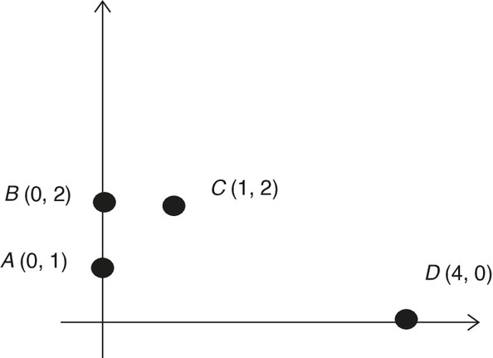

Figure 11.1 Outlier Example

Here, we define K as 2, which means we consider the neighborhood size (K) to be 2. To determine the two nearest neighbors of every house (represented as a point in Figure 11.1), we calculate the distance among all the points. We can use different metrics to measure distance; here, we use Manhattan distance.¹²

 | A | B | C
B | 1
C | 2 | 1
D | 5 | 6 | 5
As the interpoint distance matrix shows, the two nearest neighbors of point A are B and C (at distances 1 and 2, respectively), the nearest neighbors of point B are A and C, the neighbors of point C are A and B, and those of point D are A and C.

Figure 11.2 depicts the neighborhoods of A (solid line) and D (dashed line).

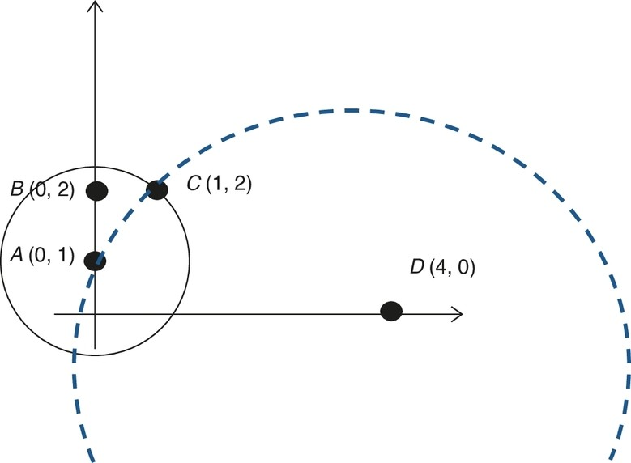
Description

Figure 11.2 Outlier Example

Reachability Distance

Our next step is to calculate the reachability distance of each point. Intuitively, it is the radius of a point’s neighborhood (i.e., the distance of the target point to the farthest point in the neighborhood). Let’s take the example of point A (whose neighbors are B and C ): The radius defining the neighborhood of A will be the distance of A to the farthest point from A, which is C. The Manhattan distance from A to C is 2. This is the reason we will calculate reachability in A’s neighborhood as 2. Even though the actual
Manhattan distance between A and B is 1, the reachability is 2, resulting in (A → B) = 2. Next, when we calculate the reachability of B, we see that the farthest points defining B’s neighborhood are both A
and C because both are at a distance of 1 from B. Therefore, the radius of B’s neighborhood is 1 and we get (B → A) = 1and (B → C) = 1. Similarly, the Manhattan distance of D from each of its neighbors A and C is 5; hence, the radius of its neighborhood is 5, and reachability is 5 for both A and C, resulting in (D → A) = 5, (D → C) = 5.
The following is the reachability distance of each point to every other point:

Reachability distance (A → B) = 2, (A → C) = 2, (B → A) = 1, (B → C) = 1,
(C → A) = 2, (C → B) = 2, (D → A) = 5, (D → C) = 5

Local Reachability Density

Having calculated the reachability distance of each point from every other point, we can now determine the density of points around each point. Intuitively, the density around any point will be high if all the neighbors are close by. In other words, density is the inverse of radius (i.e., reachability distance) of one’s neighborhood. Therefore, if the reachability distance to all the neighbors is very low (i.e., houses are close to one another), the density will be very high. This density is defined as the local reachability density (LRD) and is estimated using the following formula:

LRD = ¹

sumof reachabilitydistancetoalltheneighbors
numberof neighbors numberof neighbors
=

sumof reachabilitydistancetoalltheneighbors

Using the reachability distance calculated in the prior subsection, we can calculate LRD for each point. Next we will calculate it for point A, which has B and C as its neighbors.¹³

LRD(A) =
2

ReachabilityDistance(A → B) + ReachabilityDistance(A → C)
2

= = 0
2 + 2

Similarly, LRD(B) =
2

1 + 1

= 1, LRD(C) =
2
2 + 2

= 0.5, LRD(D) =
2
5 + 5

= 0.20

It is not surprising that the density around D is the lowest.

LOF Calculation

Finally, we calculate the local outlier factor (LOF). It is the average of the ratio of the local reachability density of a point and those of its neighbors. Hence, if we consider point D, which has A and C as its

neighbors, then it is the average of the ratio of LRD(A)
LRD(D)
and LRD(C) . Since each neighborhood has two
LRD(D)

points, we divide by 2 to calculate the average. In other words,

LOF (D) =
LRD(A)

LRD(D)
LRD(C)
+
LRD(D)

2
0.5
+

= 0.2
2
0.5

0.2

= 2.5

Similarly, LOF (A) = 1, LOF (B) = 0.5, and LOF (C) = 1. Since the LOF of D is the highest, D
can be classified as an outlier.

Let’s visually see how the LOF works by using a simple dataset of two input features: x and y. Plotting the data in Figure 11.3 gives us the following output, in which we can see that there are two big and one small cluster of observations.

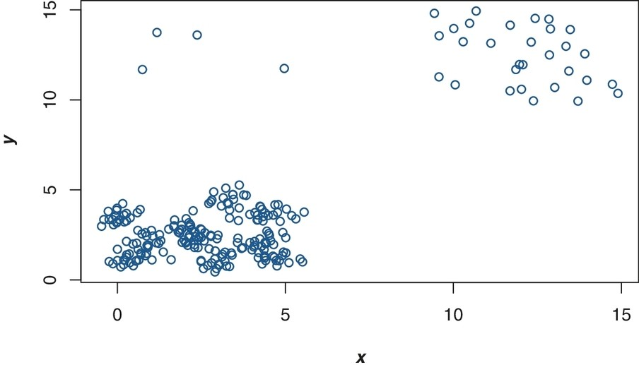

Figure 11.3 Data Plot

Recall that LOF calculations require the user to specify the size of the neighborhood. In this case, let’s provide six neighborhood sizes from 5 to 10. The model will calculate LOF scores for each observation for each neighborhood size. Since we have provided six different neighborhood sizes, it will calculate six different LOF values for each observation of the data.

Now we estimate the median LOF for each observation that currently has six LOF values. Finally, we plot data points and label LOF values greater or equal to 2 in Figure 11.4.

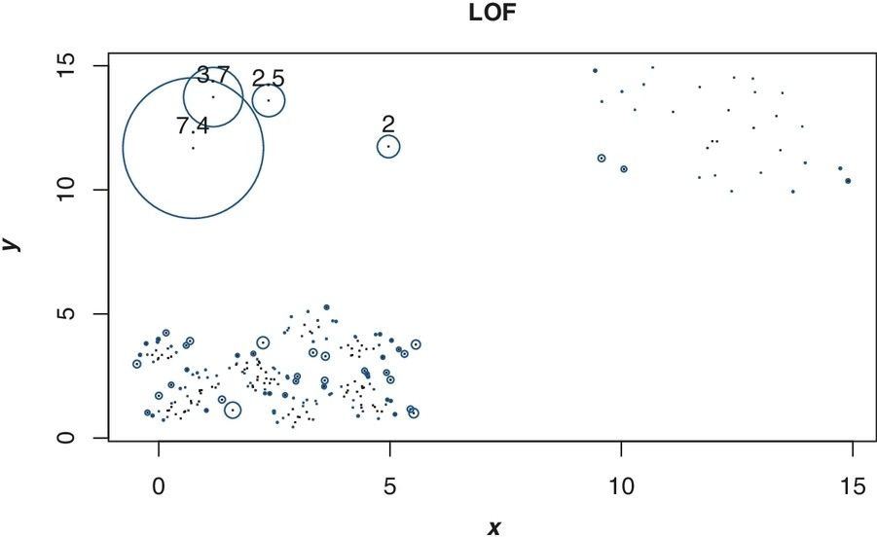
Description

Figure 11.4 LOF Values

Local Outlier Probability

One issue with LOF is that we need to set a cutoff LOF value to identify outliers with more than that cutoff value. Sometimes it is not easy to decide the correct cutoff value of LOF. To address this issue, a modification of LOF called LoOP (local outlier probability), is available. LoOP uses LOF scores to

calculate the probability of a point being an outlier. The output, therefore, is not a score but a probability value between 0 and 1. LoOP essentially determines whether an observation lies in a low-density neighborhood (potentially outlier observations) or a high-density neighborhood (regular observations). Then this information is used to calculate the probability of the observation being an outlier. LoOP makes two assumptions: (1) that, geometrically, each point’s neighborhood is centered on that point, and (2) that distances of each of the points in the neighborhood to the target point follow approximately a half-Gaussian distribution (this is distinct from assuming all distances in the dataset follow a half- Gaussian distribution).

Hence, LoOP allows us to have the best of both worlds: It doesn’t require the data to follow any distribution, but the interobservation distance estimate has nice distributional properties of being a half- Gaussian distribution in a neighborhood, S, that is amenable to statistical calculations. This enables calculating the probability of an observation being an outlier.

To the same two-input dataset on which we applied LOF, we apply LoOP and then filter out data points that have more than a 50% probability of being an outlier (see Figure 11.5).

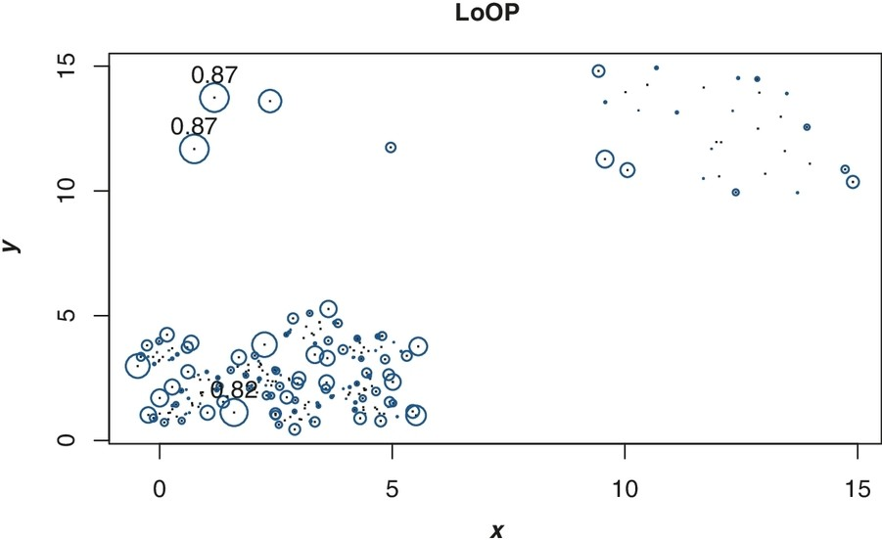

Figure 11.5 Local Outlier Probability (LoOP)
Description

DETECTING FRAUDULENT TRANSACTIONS USING LOOP
We will use the Ogenes example for understanding how fraudulent transactions can be detected using outlier detection methods. As you recall, Ogenes is a health care equipment and service company with more than 1,000 employees. It has given its employees a corporate credit card to use for business- related expenses. Based on reports, company management has determined that these cards need to be audited because it is believed some employees have been using the corporate card for personal expenses. In order to perform the audit, Ogenes knows that the input features of the fraudulent transactions will appear differently than those of legitimate transactions. Moreover, these transactions are likely to be small in number. Hence, the auditors used the LoOP local outlier detection method.
Again, a global outlier detection was not used because the reasons for the fraudulent transactions could be diverse. We will use LoOP to determine which of the transactions were fraudulent. (The data for the Ogenes example are hypothetical.)

Let’s assume that the five input features are number of daily transactions on the credit card, average distance from the corporate office and the place where the card was used, average daily amount spent using the card, number of times the card was declined each day, and number of foreign transactions for which the card was used in the last six months. In our case, LoOP is provided with 500 rows of data for the five input features and asked to identify the outliers that Ogenes would consider as potentially fraudulent.

Note that in order to verify how well the model is able to truly detect outliers given these specific input variables for a specific organization, data with labels are typically used so that the output of the model can be compared to the ground truth. In this case, we do the same; we have data with output labels— that is, we have ground truth information for whether a transaction was fraudulent. However, as mentioned earlier, we did not provide this information to LoOP but only provided LoOP with information on the five input features. Using the input features, we ask LoOP to decide which of these 500 observations appear different from the others. Once we have the output from LoOP, we can compare it to our ground truth and examine whether the observations that LoOP determined as different were indeed the fraudulent ones.

In order to compare LoOP output with the ground truth, we first convert LoOP-generated probability values into a binary response of fraud and no fraud. To convert probabilities into binary class, we set a threshold of 50% probability. If predicted probability is 50% or less, we classify that prediction as no fraud (+1). Probabilities above 50% are classified as fraud (−1). We then obtain a confusion matrix (see Chapter 9 on logistic regression for more details about the confusion matrix).
As we can see from the confusion matrix, there are eight observations that are misclassified by LoOP. These eight observations were predicted to be not fraudulent by LoOP but were actually fraudulent, which we know from the ground truth. In other words, 492 out of 500 observations were correctly
predicted by LoOP. The accuracy of LoOP, therefore, is 492 = 0. 984 (i.e., 98.4%). Therefore, using
500
LoOP, we can find out with quite a high level of accuracy which of the transactions were fraudulent. An
outlier detection method works in this case because the fraudulent transactions are not the norm and appear as outliers compared to the other transactions and, hence, are successfully detected using LoOP.

BUSINESS INSIGHTS AND CONCLUSION
The main intent of this chapter was to examine how machine-learning models can be used to identify fraudulent transactions. Specifically, in forensic accounting, the task of detecting a few fraudulent transactions among thousands of regular transactions is challenging. Hence, the method commonly used for such a process is outlier detection, in which fraudulent transactions, by the very fact that they are not a regular transaction, start exhibiting features that make them appear different. We discussed several outlier detection methods, ranging from the simple 3SD rule to global and local outlier detection methods such as Mahalanobis distance, LOF, and LoOP. LoOP is a modified version of LOF that does not need to specify a cutoff threshold to determine which observations should be considered outliers.
Using LoOP, we understood how to detect fraudulent credit card transactions. Using a confusion matrix, we determined how accurate the outlier method is in detecting fraud. In sum, this chapter discussed how machine-learning methods are being applied to many accounting functions that range beyond routine compiling of transactions to more advanced applications of robotic process automation in audits and identifying tax frauds in forensic accounting.

IMPLEMENTATION USING R: OUTLIER DETECTION FOR IDENTIFYING FRAUDULENT TRANSACTIONS

LoOP uses the 500 rows of data with the five input features to identify the outliers that Ogenes would consider as potentially fraudulent. Let’s understand the R code line by line. The library needed are caret and DDoutlier.^{14,15}
options(scipen = 100) suppresses scientific e notations.¹⁶ Next we import the data. The dataset has labels indicating fraudulent transactions, which helps us verify how well this method is working.
However, in the real world there will be no labels attached to the dataset, and since LoOP is an unsupervised method, it does not require any labels. Therefore, in the next line of code (fraud_data[,1:5]), we just choose the five features of the dataset. Recall that this method requires a user to specify the neighborhood size, so we are providing 11 different neighborhood size values in sapply(50:60, function(k) LOOP(fraud_predictors, k)). Here, sapply applies a function (i.e., LOOP) to all the values of neighborhood size between 50 and 60. This code generates 11 values of LoOP, one for each neighborhood size, including the endpoints of 50 and 60. In order to obtain the median values, we use apply(loop,1,median), which provides the median LoOP value for each observation.

options(scipen = 999) library(DDoutlier)library(caret)
fraud_data <- read.csv(url("http://data.mishra.us/files/chapter_outlier/fraud_dataset.csv")
fraud_predictors <- fraud_data[,1:5]
loop<- sapply(50:60, function(k) LOOP(fraud_predictors,k))
loop<-apply(loop,1,median)

Using the input features, we ask LoOP to decide which of these 500 observations appear different from the remaining observations. We then compare them to our ground truth to see whether the observations that LoOP determined as different were indeed the fraudulent ones. To convert LoOP-generated probabilities into binary class, we set a threshold of 50% probability. If predicted probability is 50% or less, we classify that prediction as no fraud (+1). Probabilities above 50% are classified as fraud (−1). loop_binary<-ifelse(loop > 0.5, −1,1) performs the conversion from probabilities to binary response and stores it in a new variable loop_binary. We then convert this new variable into a factor by using as.factor(loop_binary). Finally, using the confusionMatrix() function, we create a confusion matrix.

loop_binary<-ifelse(loop > 0.5, -1,1)
loop_binary<-as.factor(loop_binary)
library(caret)
cm = confusionMatrix(loop_binary,as.factor(fraud_data$fraud),
positive = "1")
cm$table

## |  | Reference
## | Prediction | -1 | 1
## | -1 | 42 | 0
## | 1 | 8 | 450

Out of 500 observations, 492 were correctly predicted by LoOP, while only 8 observations were misclassified by LoOP.

APPENDIX: GLOSSARY OF ACCOUNTING TERMS

Annual Audit Plan: A comprehensive plan that outlines the scheduled auditing activities for a year to help conduct audits systematically and review key risk areas.

Balanced Scorecard: A performance metric used to identify and strategically improve some internal functions of an organization to improve outcomes.

Contract Analysis: The evaluation of contractual documents to understand, organize, and manage several financial obligations of an organization such as reviewing the payment schedule, identifying financial and liability clauses, evaluating insurance needs, ensuring compliance with current regulatory accounting standards, and so on.

Corporate Credit Card Fraud: This could include the unauthorized use of a company-issued credit card for personal expenses or financial gain.

Debt Defaults: Failure to repay a debt, including the principal or interest, by a borrower at the agreed-upon time.

Financial Theft: The process of illegally taking money or other financial assets from an organization.

Invoice Matching: The process of comparing invoices to purchase orders or delivery receipts to ensure accuracy and consistency in financial transactions and recordkeeping.

Key Risk Indicators: Metrics or measures used to identify and evaluate risks that an organization might face, assisting in monitoring and managing potential threats effectively.

Lease Accounting: Accounting for the various aspects related to leased assets, such as recognizing the assets that are leased, correctly presenting the information per regulations, and disclosing the payment timelines and contingencies related to leases in financial statements.

Money Laundering: The process by which money earned from illegal activities, such as organized crime, embezzlement, corruption, and tax evasion, is made to appear legal.

Revenue Recognition Standards: Guidelines that determine when and how revenue is reported in financial statements, ensuring consistency and accuracy in financial reporting.

Robotic Process Automation (RPA): A type of automation technology that uses bots or other software to perform repetitive tasks, with the aim of improving efficiency and accuracy. These tasks could include data entry and basic administrative tasks.

Securities Fraud: A deceptive practice related to stocks, bonds, or other investments, such as insider trading, spreading fake news, lying about a company’s financial health, or misrepresenting

information to investors.

Tax-Related Activities: A wide variety of activities encompassed within an organization’s accounting operations, such as tax planning that includes developing strategies to minimize tax liabilities as well as future financial planning to estimate future tax liabilities. Tax-related activities could also include calculating payroll taxes, sales taxes, operations taxes, and the like to ensure that the organization’s functions are complaint with the relevant tax laws and regulations.

Tax Evasion: An illegal act in which an individual or business intentionally avoids paying their true tax liability. This could involve underreporting income, inflating deductions, hiding money and its interest in offshore accounts, or not filing tax returns altogether.

UNDERSTANDING THE CHAPTER
- Can machine-learning models be used for making accounting decisions? Give one example where efficiency increases when such models are used.
- Are outliers in a dataset always noise? Should outliers always be removed from the dataset before performing any analysis?
- The local outlier factor (LOF) method relies on which of the following metrics?
  - Euclidean distance
  - Mahalanobis distance
  - Minkowski distance
  - Manhattan distance
- The LOF is representative of which of the following?
  - The inverse of the variance–covariance matrix
  - The sum of absolute deviations from the mean
  - The average local reachability density (LRD) of all data points
  - The LRD of a data point in relation to that of its neighbors
- If the LRD of a data point is low, then .
  - distance to its neighbors is small
  - distance to its neighbors is large
  - the number of neighbors is large
  - the number of outliers is small
- What is one assumption of global outlier detection methods?
  - One single mechanism created the dataset.
  - The underlying mechanism generates a normal distribution.
  - The data are independent and identically distributed.
  - Outliers are always at least three standard deviations away from the sample mean.
- What is the difference between global outlier detection and local outlier detection?
  - Global outlier detection assumes a global mechanism created the dataset.
  - Local outlier detection assumes that the dataset is drawn from a single mechanism.
  - The detection methods are the same but apply to different business cases.
  - Local outlier detection cannot work on a global, or macro, dataset.

ENDNOTES

- PwC, “Robotic Process Automation: A Primer for Internal Audit Professionals,” 2018, https://www.pwc.com/sg/en/publications/assets/ra-robotic-process-automation-for-ia.pdf.

- Haq, Izhar, Michael Abatemarco, and Jeffrey Hoops, “The Development of Machine Learning and Its Implications for Public Accounting,” The CPA Journal 90, no. 6 (2020): 6–9.

- Ranta, Mikko, Mika Ylinen, and Marko Järvenpää, “Machine Learning in Management Accounting Research: Literature Review and Pathways for the Future,” European Accounting Review 32, no. 3 (2023): 607–636.

- “Fraud Costs the Global Economy Over US$5 Trillion,” Crowe, July 12, 2019, https://www.crowe.com/global/news/fraud-costs-the-global-economy-over-us$5-trillion.

- West, Darrell M., “Using AI and Machine Learning to Reduce Government Fraud,” Brookings Institution, September 10, 2021, https://www.brookings.edu/research/using-ai-and-machine-learning-to- reduce-government-fraud/.

- Dempsey, Michael, “How to Investigate a Firm With 60 Million Documents,” BBC, January 19, 2021, https://www.bbc.com/news/business-55306139.

- West, “Using AI and Machine Learning.”

- Hawkins, Douglas M., Identification of Outliers, Vol. 11 (London: Chapman and Hall, 1980).

- Hampel, Frank R., “The Influence Curve and Its Role in Robust Estimation,” Journal of the American Statistical Association 69, no. 346 (1974): 383–393.

- Rousseeuw, Peter J., “Least Median of Squares Regression,” Journal of the American Statistical Association 79, no. 388 (1984): 871–880.

- Rousseeuw, Peter J., and Katrien Van Driessen, “A Fast Algorithm for the Minimum Covariance Determinant Estimator,” Technometrics 41, no. 3 (1999): 212–223.

- Manhattan distance is d_{manhattan} = ∑^{n}
i=1
|x_{i} − y_{i}|

- Note that the “sum of reachability distance to all the neighbors” is essentially the number of neighbors multiplied by the reachability distance.

- Kuhn, Max, “caret: Classification and Regression Training,” R package version 6.0-94 (March 21, 2023), https://CRAN.R-project.org/package=caret.

- Jacob H. Madsen (2022). DDoutlier: Distance & Density-Based Outlier Detection in R. R package version 0.1.0. https://cran.r-project.org/web/packages/DDoutlier/DDoutlier.pdf

- In these e notations, 24 becomes 2.4 × 10^1 or 2.4e + 01.

Descriptions of Images and Figures
Back to Figure

The figure is a graph with two nodes on y-axis labeled B (0, 2) on the top and A (0, 1) at the bottom. On the right side of the x-axis is a node labeled D (4, 0). Within the graph is a node labeled C (1, 2). A circle encloses the two nodes on the y-axis. A dotted semicircle is present from the left side of the graph to right side intersecting the nodes A (0, 1) and C (1, 2)

Back to Figure

The figure is a graph with y-axis marked 0 to 15 and x-axis are the markings 0 to 15. On the bottom left are small circular nodes clustered into a single group. On the top left are four circular nodes and top right is a group of circular nodes. The four circular nodes on the top left are enclosed in a circle and labeled 7.4, 3.7, 2.5 and 2. On the top is the description LOF.

Back to Figure

The figure is a graph with y-axis marked 0 to 15 and x-axis are the markings 0 to 15. On the bottom left are small circular nodes clustered into a single group. On the top left are four circular nodes and top right is a group of circular nodes. The two circular nodes on the top left are enclosed in a circle and labeled 0.87. On the top is the description LoOP.

OceanofPDF.com

